**Mission: Predictable**

**A Virtual Machine Learning Hackathon to Battle Covid-19**

Your mission, should you choose to accept it, involves forming a team and putting your newfound skills to use in the battle against COVID-19. At the end of your mission, you will be assembled by the judges to present your project. The winning team walks away with $5 000 in AWS credits and free access to the A Cloud Guru platform to continue their learning journey!



We are looking for unique solutions, apps and technologies to solve social challenges today. We are most interested in solutions and approaches related to COVID-19.

We will also accept projects that create novel approaches to other social impact challenges in healthcare, climate change, anything at the city level, or other challenges you think you can apply machine learning or artificial intelligence to!

**Problem Statement**

Your final project should have a clearly stated problem statement, and at least one paragraph explaining how your project aims to address this challenge.

**GitHub/Jupyter notebooks**

A complete submission includes a link to access the code. This can be via your Jupyter notebook or a GitHub repository link.

**Amazon Web Services**

You must generate your model using Amazon SageMaker (either console or Jupyter hosted notebook).

You can use additional Amazon Web Services resources, as well as other technologies to create your project.

**Usability**

Judges will also be assessing whether your project could be used in a real world setting.

**Presentation and Judging Process**

For your submission on August 14, we will send around a form that will prompt you for information like your team members’ names and bios, the link to the code, your problem statement and explanation of your solution, and an upload area for your presentation.

This presentation will expand on your problem statement and solution paragraph.

It can be submitted as slides, a PDF case study, a video, or other similar formats.

This presentation will help judges understand your work in a more full way.

These presentations and profiles will also be publicly available via Women Who Code after the hackathon, to highlight everyone’s projects.

All August 14 submissions will be assessed, and the top 7 projects, based on the criteria above, will be selected.

These 7 teams will be notified Monday, August 17 that they are moving on to the Women Who Code/AWS live judging on August 19.

The top 7 teams will present their project live via video chat to the entire judging team, and an overall winner will be selected.

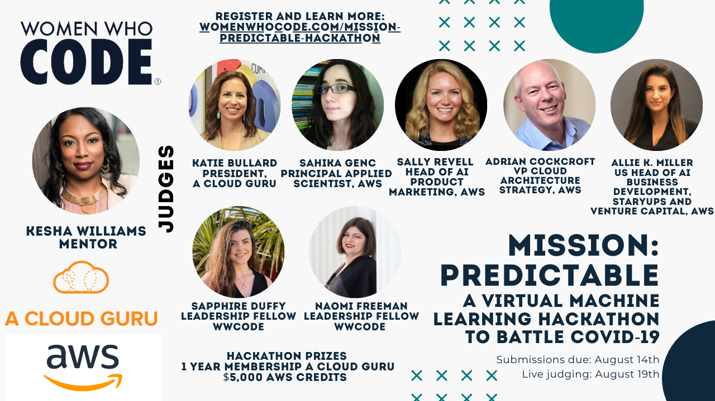

**Datasets**

You can use any data sets that you like.

Please feel free to review Kesha’s video workshop series for ideas for COVID-19 datasets.

Other COVID-19 datasets can be found here:

[Novel Corona Virus 2019 Dataset](https://www.kaggle.com/sudalairajkumar/novel-corona-virus-2019-dataset) (kaggle)

[COVID-19 Coronavirus Data](https://data.europa.eu/euodp/en/data/dataset/covid-19-coronavirus-data) (EU Open Data Portal)

[COVID-19 Data Collection](https://dataverse.harvard.edu/dataverse/covid19) (Harvard Dataverse)

[A Variety of Datasets](https://academicdatascience.org/covid#body-content-2) (Academic Data Science Alliance)

You can also check your federal and municipal government websites for more datasets. The Government of Canada, for example, offers data sets ranging from seasonal fish locations to real estate. City of Toronto offers data sets about community housing and bike share docking locations.

**Workshops**

Kesha Williams, AWS Machine Learning Hero, has prepared us for this mission with a series of guided workshops introducing the tools and techniques needed to use machine learning to battle the invisible enemy, COVID-19. She will continue to be available as a mentor through the hackathon!

You can access all of the workshops here:

Introduction to Machine Learning for Social Good (CONNECT Digital)

[Watch here](https://www.youtube.com/watch?v=quZBrdpnrRk&list=PLVcEZG2JPVhcTOa5eBp6TYucuon-aXgWf&index=5)

Video Workshop #1: Machine Learning Techniques to Battle COVID-19

[Watch here](https://www.youtube.com/watch?v=DbQ8O8Yeovc&list=PLVcEZG2JPVhcOGRWbtmocId5_TBNi-ZG2&index=12)

Video Workshop #2: Obtain, Dissect, and Understand COVID-19 Data

[Watch here](https://www.youtube.com/watch?v=019ZGqEvpyA&list=PLVcEZG2JPVhcUlxaxicFyyS2gxAC4XNm_)

Video Workshop #3: Train Your Machine Learning Model to Help in the Fight to Battle COVID-19

[Watch here](https://www.youtube.com/watch?v=-lUUzN5Tsv4&feature=youtu.be)